Quick Snacks *Developer Guide*

|  |  |  |
| --- | --- | --- |
| **Supervisor.** | **Sir Sameer faisal** | |
| **Batch.** | **2212c2** | |
| **Group.** | A | |
| **Serial No.** | **Enrollment Number** | **Student Name** |
| 1. | 1445169 | Ahtesham |
| 2. | 1428847 | Umme Fatima |
| 4. | 1446623 | Abdullah |
| 3. | 1443726 | Rabia Malik |

***1.Home (index.html)***

***Figure 1: Home page of Quick Snacks***

Our website aims to create a comprehensive and interactive space for snack enthusiasts to explore, shop, engage, and stay updated on the latest snack trends.

• Our homepage delivers an enticing introduction to a variety of quick snacks. It allows users to explore, learn, and shop for snacks, engage in community discussions, and receive personalized recommendations. Users can easily navigate through different sections, shop for popular snacks, engage with a snack-loving community, and stay updated on trends and reviews.

*Code Of Home Page*

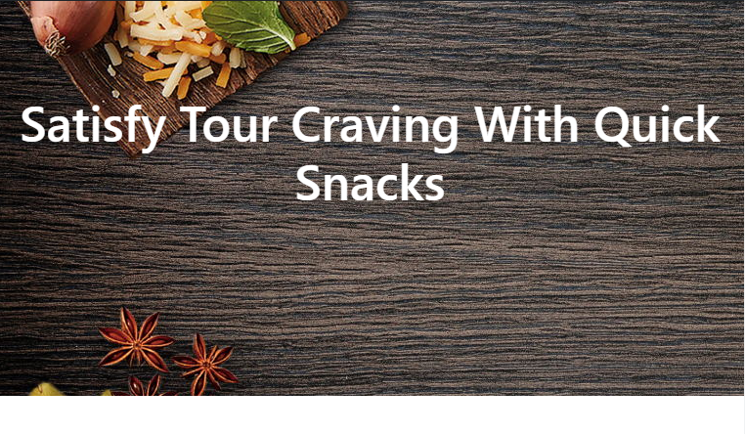

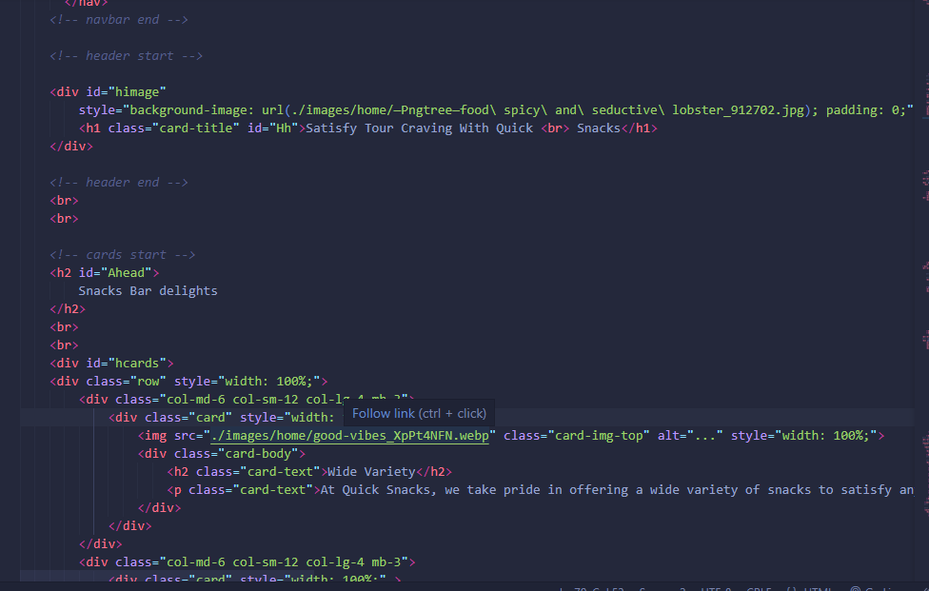

**2.Navbar (index.html)**

We have given FIVE essentials. By clicking any of the essentials you will be redirected to the linked page. (Index.html)



***Figure 2: Navbar***

*Code Of Navbar*

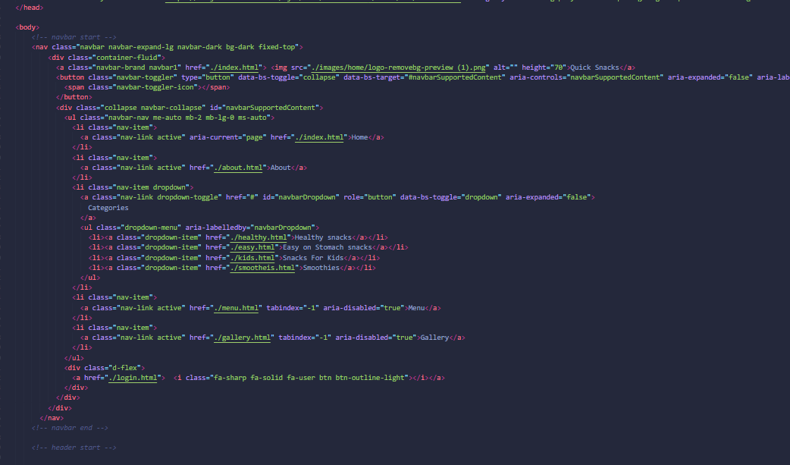

**3.Menu(menu.html)**

• We recommend the best quality snacks from around the world.

• We every type of snacks in our menu and it is also categorized for you.

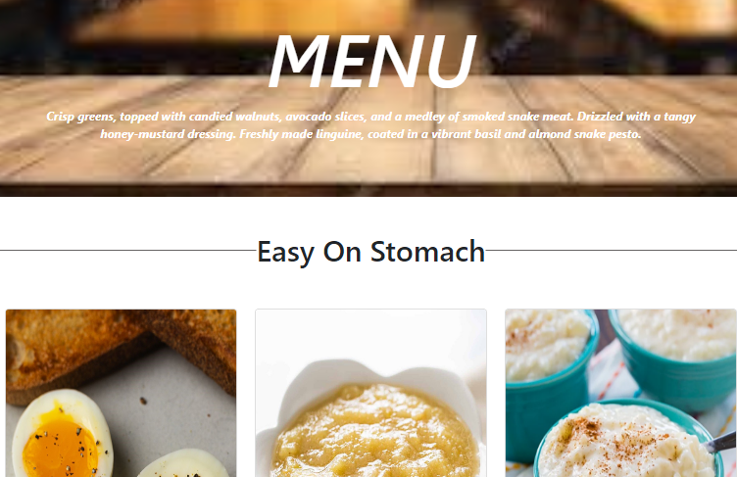

***Figure 3: Beach***

*Code Of menu*

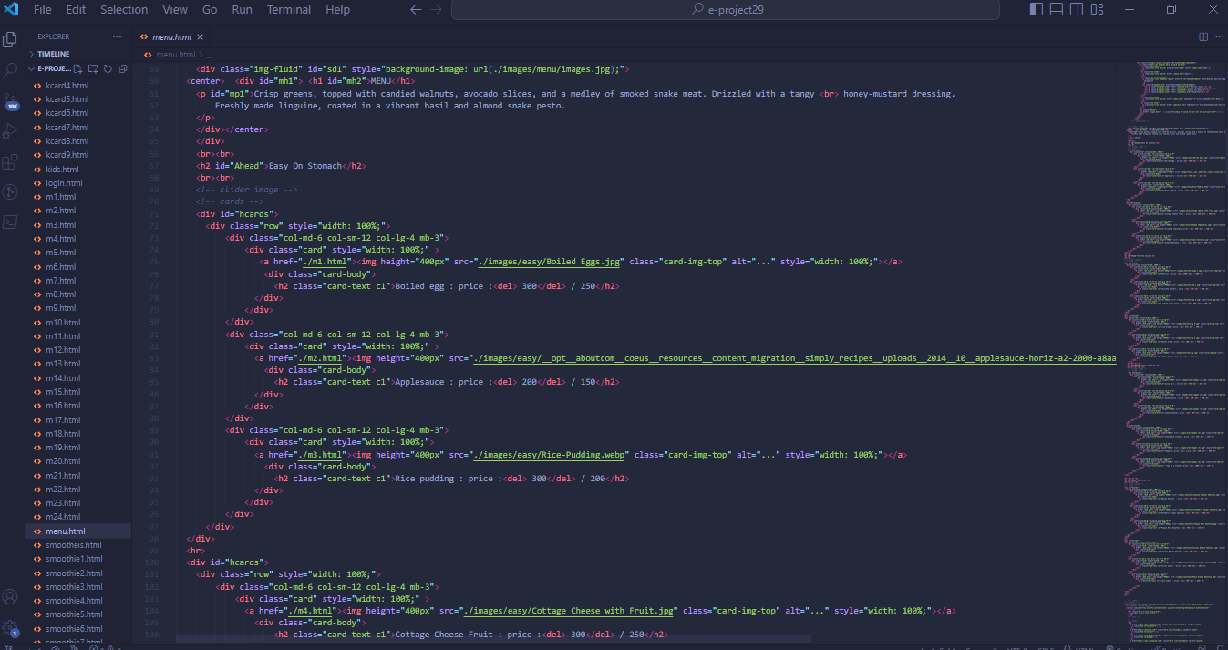

**4.Gallery(gallery.html)**

*We have given some of the most beautiful views of the Quick snacks we recommend to our users for a better understanding.*

* ***Here we display some images of the beaches we recommend.***

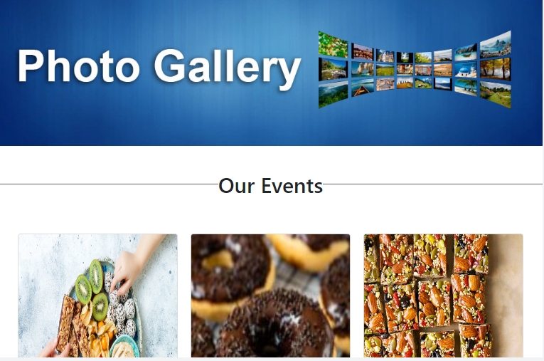

***Figure 4: Gallery***

*Code Of Gallery*

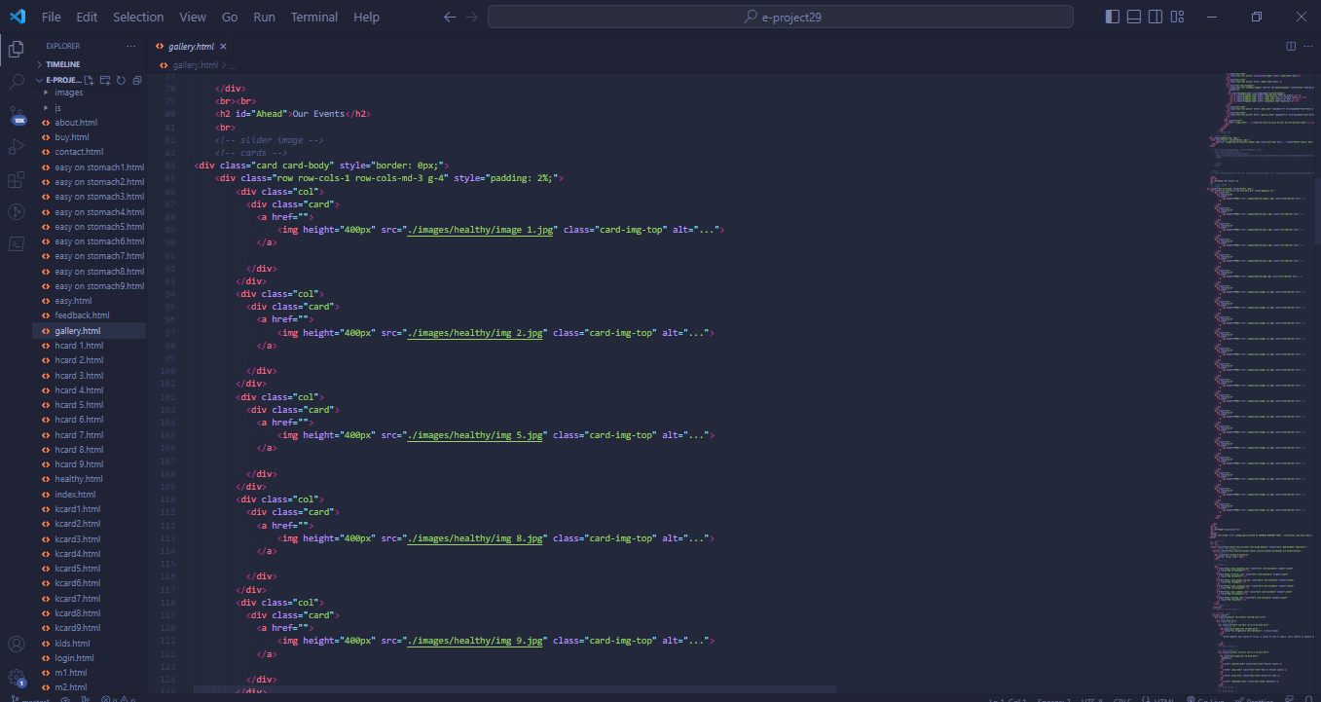

***5.About Us (about.html)***

***“Description about our website”***

*We have given the user some information about the creators and our website.*

* ***Information about our website***
* ***Information about the creators***

***Figure 5: About us***

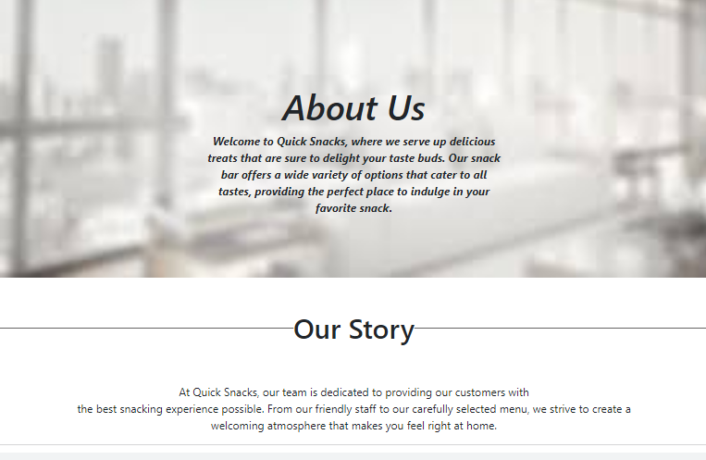

*Code Of About Us*

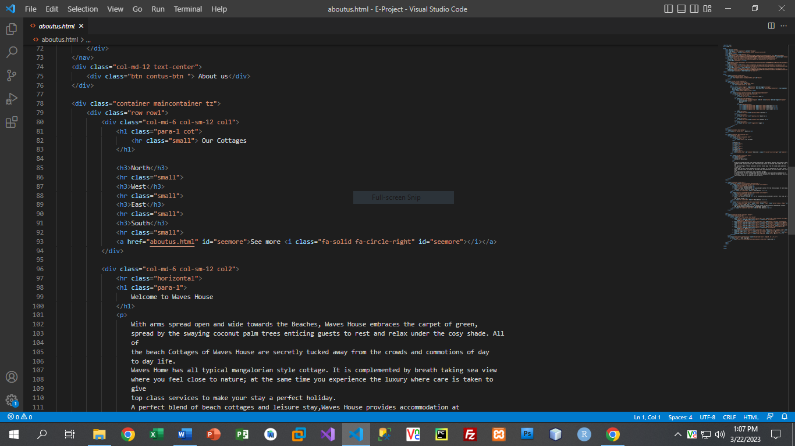

***6.Contact Us (contact.html)***

*We have given the user information to contact us, leave reviews and send queries.*

* ***Information to contact us has been displayed on this page.***
* ***Our address has been displayed with our phone number.***
* ***Review box has been displayed at the end of the page to get the satisfaction of our user.***

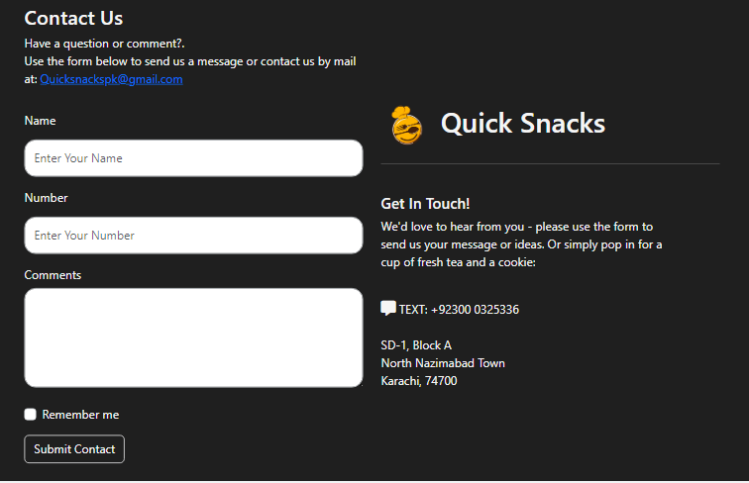

***Figure 6 : Contact us***

*Code Of Contact Us*

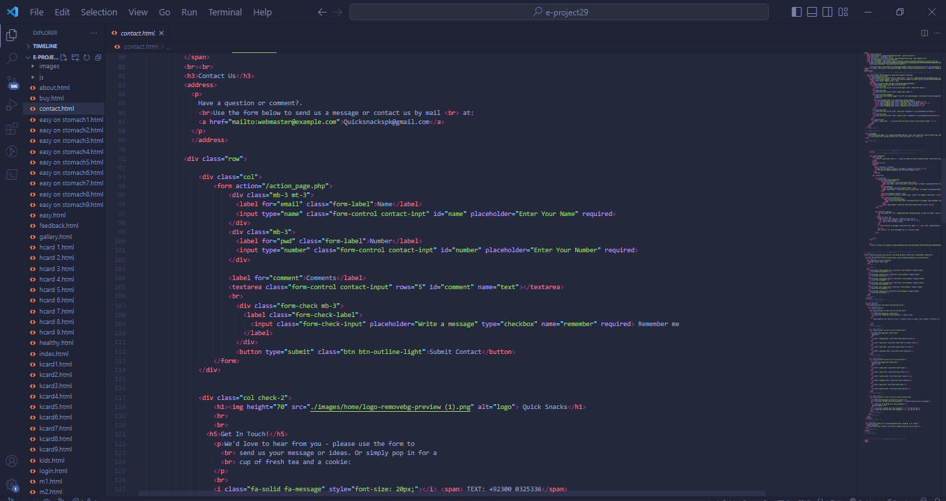

***7. Login(login.html):***

*It is a necessity to sign up and login afterwards to get a look at our website after successfully logging in the user will be redirecting to our homepage and then can navigate all over the website.*

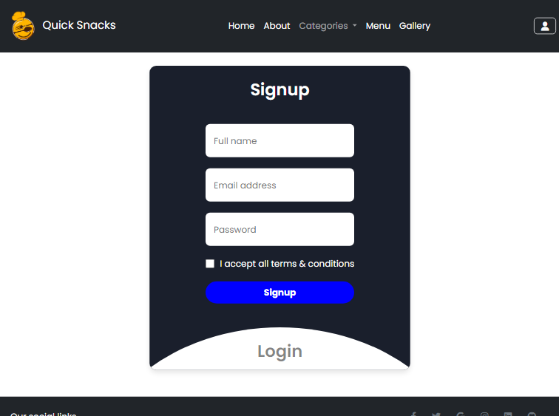

***Figure 6: Login***

*Code Of Login*

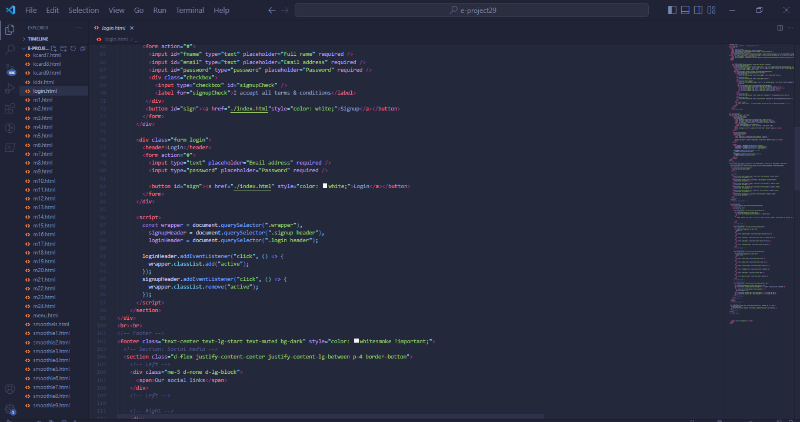

***9.Footer (index .html):***

*We have given some links in the footer which will redirect u to social media platforms and we have added hover affects for a more prominent look.*

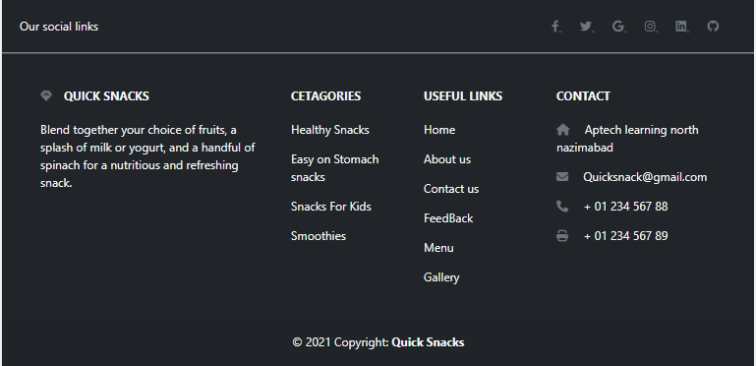

***Figure 9: Footer***

*Code Of Footer*

